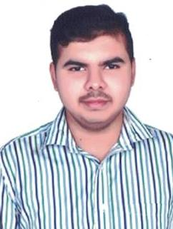

**Pramod Kumar B K**

Mob: +91 8553461129  
**Email:** [**pramodkumar1599@gmail.com**](mailto:pramodkumar1599@gmail.com)

**EXECUTIVE SUMMARY**

To obtain a position that will enable me to prove myself as an important part of the organisation being a committed team member and to contribute towards the growth of the organisation.

**EDUCATION**

2017 **Imarticus Learning**  **Bangalore, India**

* + - Derivatives and Advance Derivatives
    - Swaps, Money Markets, FX Market
    - End to end Trade life cycle

2013 - 2016 **B.N.M College, B’lore University**  **Bangalore, India**

* Bachelors of Business Management (55%)

2012 - 2013 **National College**  **Bangalore, India**

* P.U.C (60%)

2011 **NSVK SCHOOL,**  **Bangalore, India**

* S.S.L.C (73.92%)

**ACADEMIC PROJECT**

**Title:**

**“A Study on Quality of Work Life of employees with reference to Aditya Birla, Doddabalapur.”**

**WORK EXPERIENCE**

3 months’ internship in **Societal Generale. (18th Jan-18th April 2018)**

Worked on project **Revenue System**.

Roles and Responsibilities:

1. Reconciliation of Brokerage.
2. Interacting with FO and MO.
3. There were many aged queries. I took the initiative and was able to resolve those queries.
4. Drafting mails to FO and MO.

**ACHIEVEMENTS**

* Won 1st place in an event Product Launch competition
* Won 3rd place trophy in the interclass Hindi Quiz Competition Cultural meet.